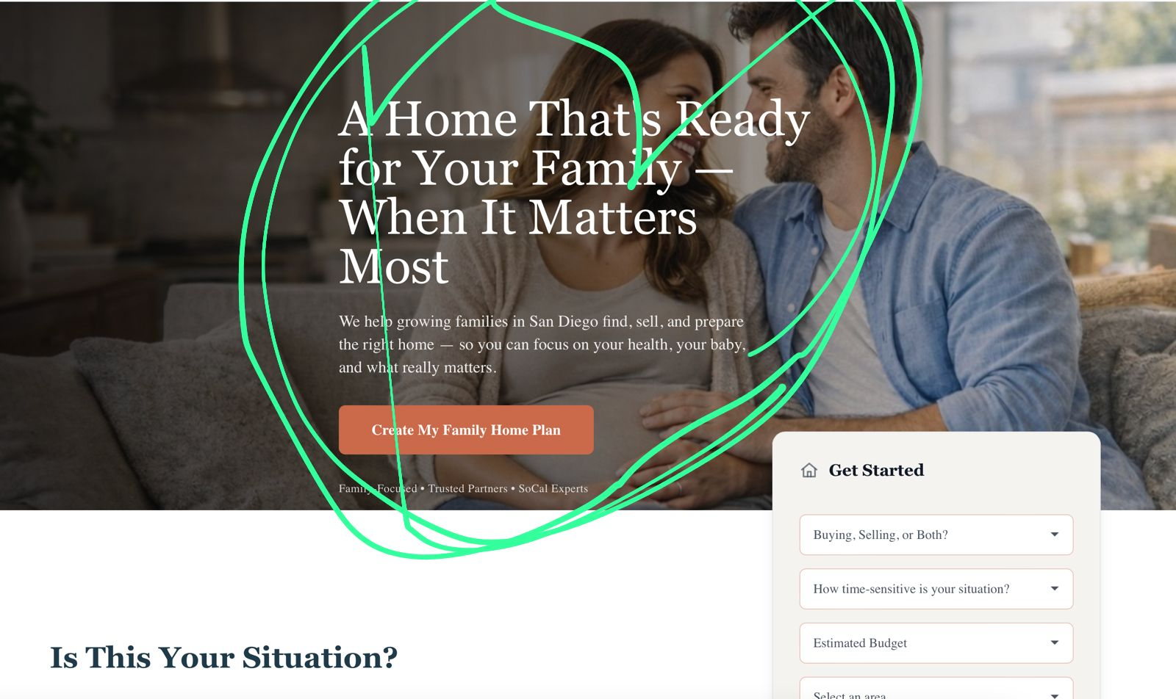
Text is in the middle!!! Move it to left !

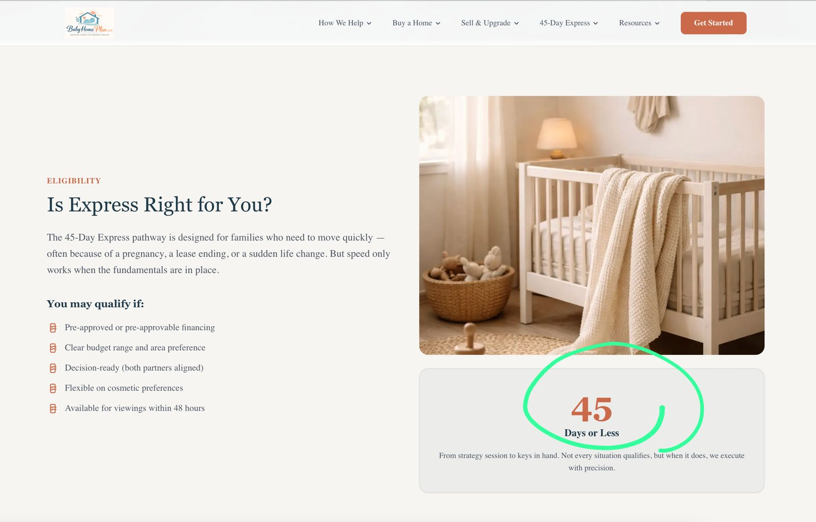
We change this in 33 days

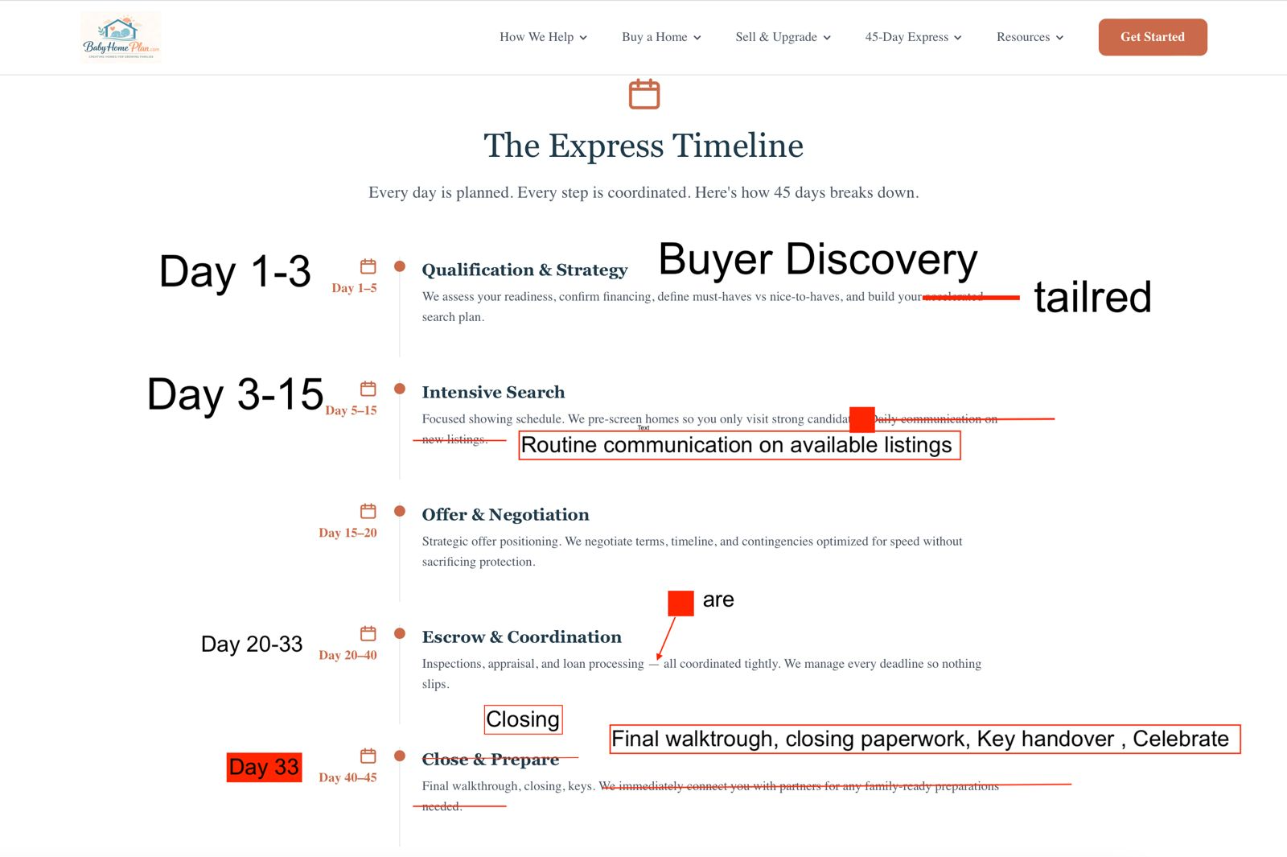Check also the dictation
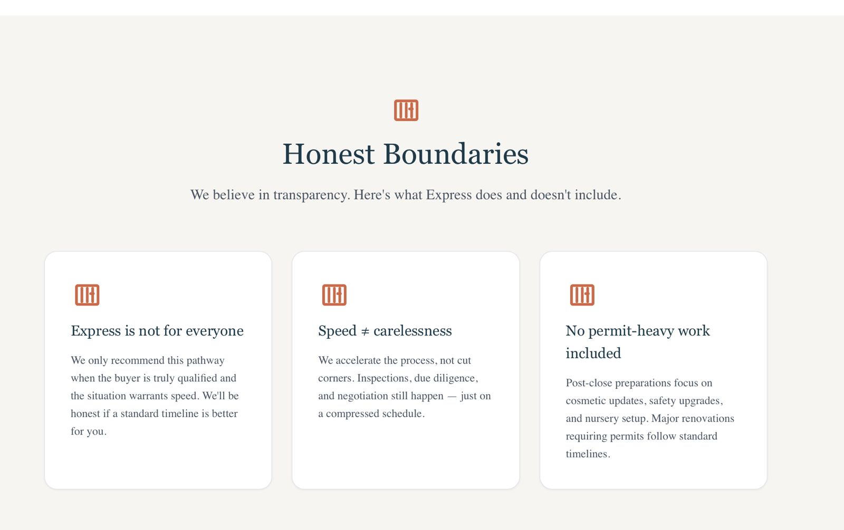
Checke the logos to this 4 :

<svg xmlns="http://www.w3.org/2000/svg" width="48" height="48" viewBox="0 0 48 48" fill="none" style="color:#C56B55">
<rect x="6" y="6" width="36" height="36" rx="10" stroke="currentColor" stroke-width="2"/>
<circle cx="20" cy="21" r="5" stroke="currentColor" stroke-width="2"/>
<path d="M12 36c2.2-6 13.8-6 16 0" stroke="currentColor" stroke-width="2" stroke-linecap="round"/>
<circle cx="32" cy="31" r="6" stroke="currentColor" stroke-width="2"/>
<path d="M29.5 31l1.8 1.8 3.7-4" stroke="currentColor" stroke-width="2" stroke-linecap="round" stroke-linejoin="round"/>
</svg>
Express

<svg xmlns="http://www.w3.org/2000/svg" width="48" height="48" viewBox="0 0 48 48" fill="none" style="color:#C56B55">
<rect x="6" y="6" width="36" height="36" rx="10" stroke="currentColor" stroke-width="2"/>
<circle cx="23" cy="27" r="10" stroke="currentColor" stroke-width="2"/>
<path d="M20 14h6" stroke="currentColor" stroke-width="2" stroke-linecap="round"/>
<path d="M26.5 15.5l2.5 2.5" stroke="currentColor" stroke-width="2" stroke-linecap="round"/>
<path d="M23 27l4-3" stroke="currentColor" stroke-width="2" stroke-linecap="round"/>
<circle cx="34" cy="32" r="5" stroke="currentColor" stroke-width="2"/>
<path d="M32 32l1.4 1.4 3-3.4" stroke="currentColor" stroke-width="2" stroke-linecap="round" stroke-linejoin="round"/>
</svg>
Speed

<svg xmlns="http://www.w3.org/2000/svg" width="48" height="48" viewBox="0 0 48 48" fill="none" style="color:#C56B55">
<rect x="6" y="6" width="36" height="36" rx="10" stroke="currentColor" stroke-width="2"/>
<path d="M17 15h10l4 4v14H17V15z" stroke="currentColor" stroke-width="2" stroke-linejoin="round"/>
<path d="M27 15v4h4" stroke="currentColor" stroke-width="2" stroke-linejoin="round"/>
<path d="M19.5 23h9" stroke="currentColor" stroke-width="2" stroke-linecap="round"/>
<circle cx="22" cy="30" r="3" stroke="currentColor" stroke-width="2"/>
<path d="M16 36L34 18" stroke="currentColor" stroke-width="2" stroke-linecap="round"/>
</svg>
no permit

<svg xmlns="http://www.w3.org/2000/svg" width="48" height="48" viewBox="0 0 48 48" fill="none" style="color:#C56B55">
<rect x="6" y="6" width="36" height="36" rx="10" stroke="currentColor" stroke-width="2"/>
<path d="M14 26c2.8-5 7-8 10-8s7.2 3 10 8c-2.8 5-7 8-10 8s-7.2-3-10-8z"
stroke="currentColor" stroke-width="2" stroke-linejoin="round"/>
<circle cx="24" cy="26" r="3" stroke="currentColor" stroke-width="2"/>
<path d="M24 18v16" stroke="currentColor" stroke-width="2" stroke-linecap="round" opacity="0.9"/>
</svg>
Honest

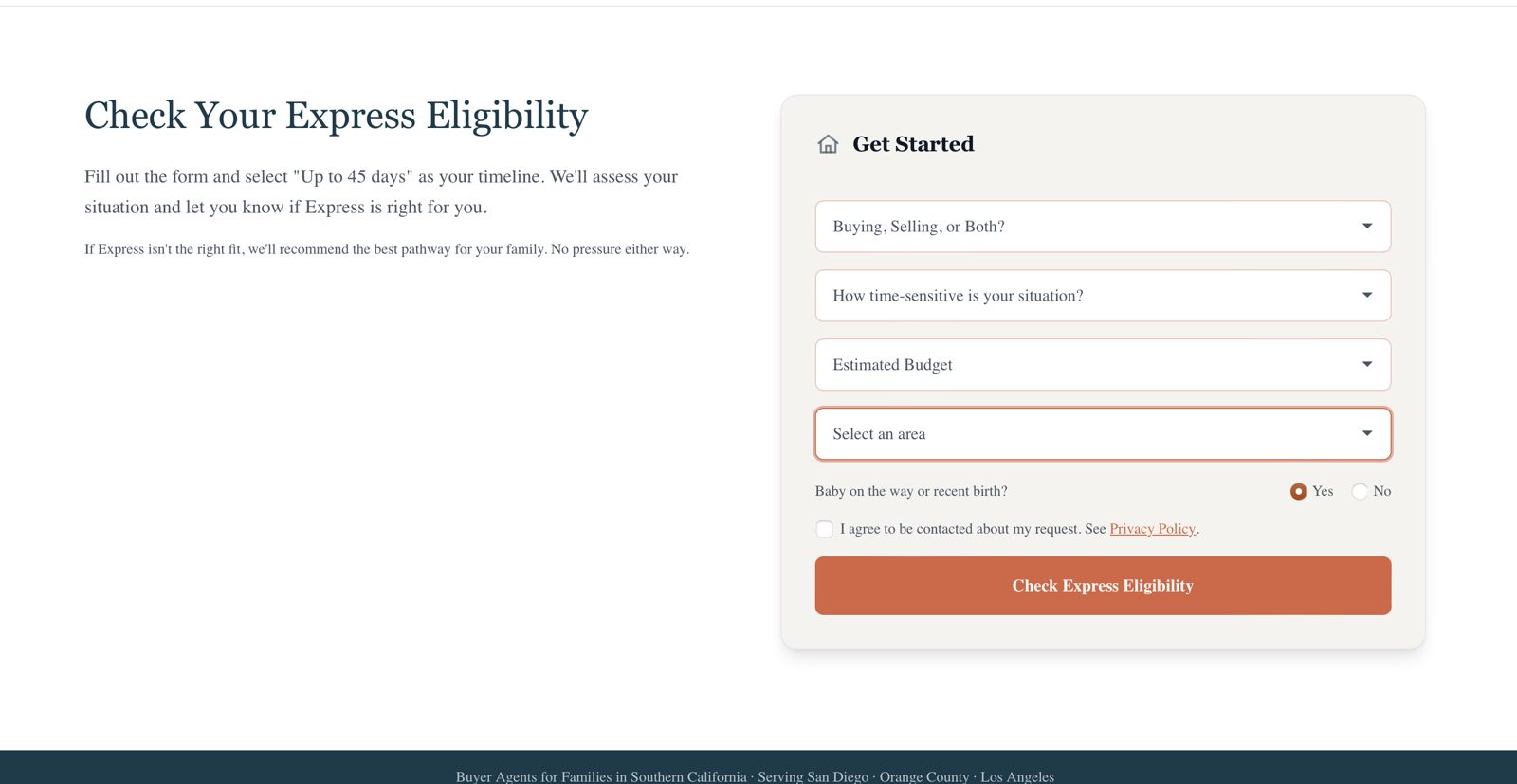

Please update the left column in the “Check Your Express Eligibility” section with the following marketing copy (Variant B) and match the existing typography/layout.

GOAL
- Build trust and clarity
- Increase conversions without sounding “salesy”
- Visually balance the left text area with the height of the form card on the right

LEFT COLUMN CONTENT (final)
H1:
"Check Your Express Eligibility"

Lead (2–3 sentences, below H1):
"If time is the constraint, clarity is the advantage. Share a few details and we’ll tell you if the Express timeline (up to 45 days) is realistic for your situation—without cutting corners.
If Express isn’t the best fit, we’ll recommend the smartest timeline for your family."

Bullets (with a check icon or simple bullet styling):
- "A straight answer on whether Express is viable"
- "A safe speed plan for inspections, negotiations, and closing logistics"
- "A recommendation that protects your time and your outcomes"
- "Clear expectations on what’s possible in your target area and budget"

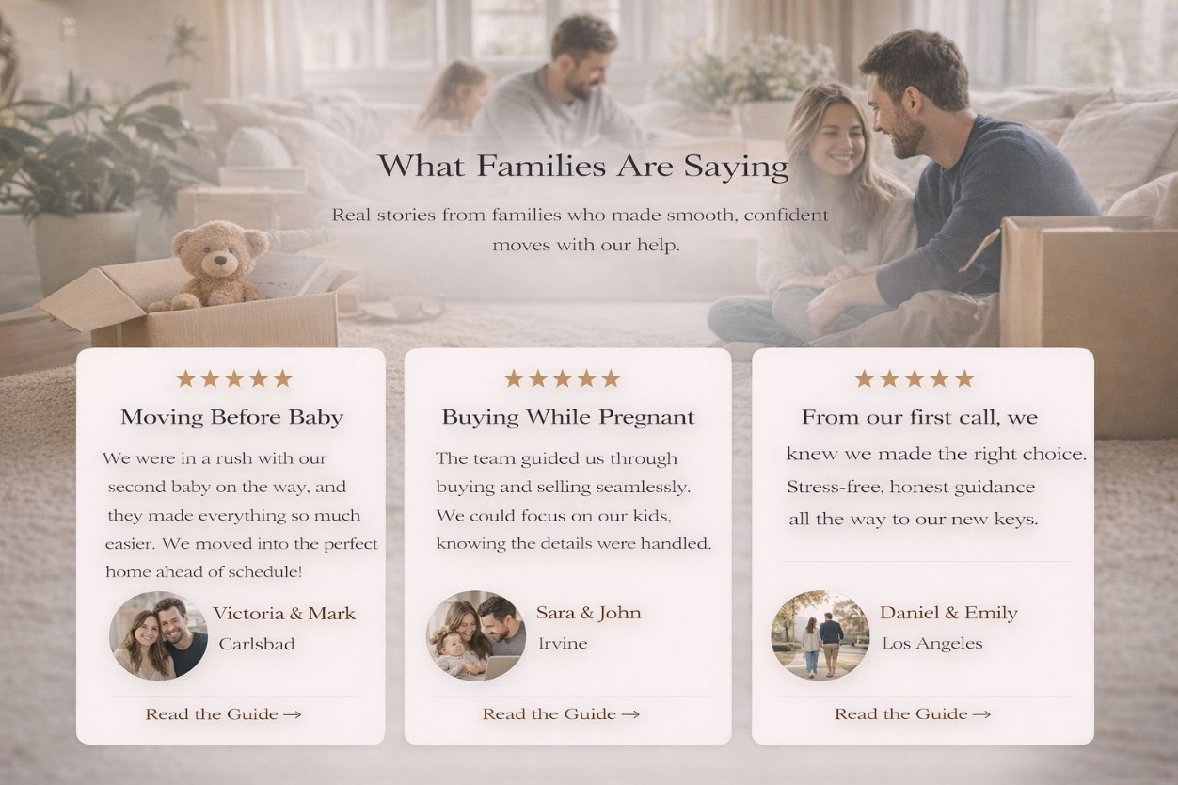

Add this in the home page

